Ideation Phase
Idea Prioritization Template
Date | 31 OCTOBER 2025
Team ID | NM2025TMID04230
Project Name | Education Organisation Using ServiceNow
Maximum Marks | 4 Marks

Education Organisation Using ServiceNow Template :
In today’s rapidly evolving digital landscape, educational organizations are increasingly seeking innovative ways to improve efficiency, enhance user experience, and streamline operations. ServiceNow, a leading cloud-based platform, offers powerful tools for automating workflows, managing services, and improving communication across departments.
The adoption of ServiceNow within an educational organization enables the integration of academic, administrative, and IT services into a unified system. This ensures faster response times, better visibility into institutional processes, and improved collaboration among faculty, students, and support staff. By leveraging ServiceNow’s capabilities, educational institutions can transform manual, paper-based processes into intelligent digital workflows — from managing student inquiries and IT incidents to automating HR and facility requests.
Implementing ServiceNow not only enhances service delivery and operational transparency but also supports data-driven decision-making and continuous improvement. Ultimately, it empowers the institution to provide a seamless digital experience for all stakeholders while focusing on its core mission: delivering high-quality education.

Step-1 : Team Gathering, Collaboration and Select the Problem Statement
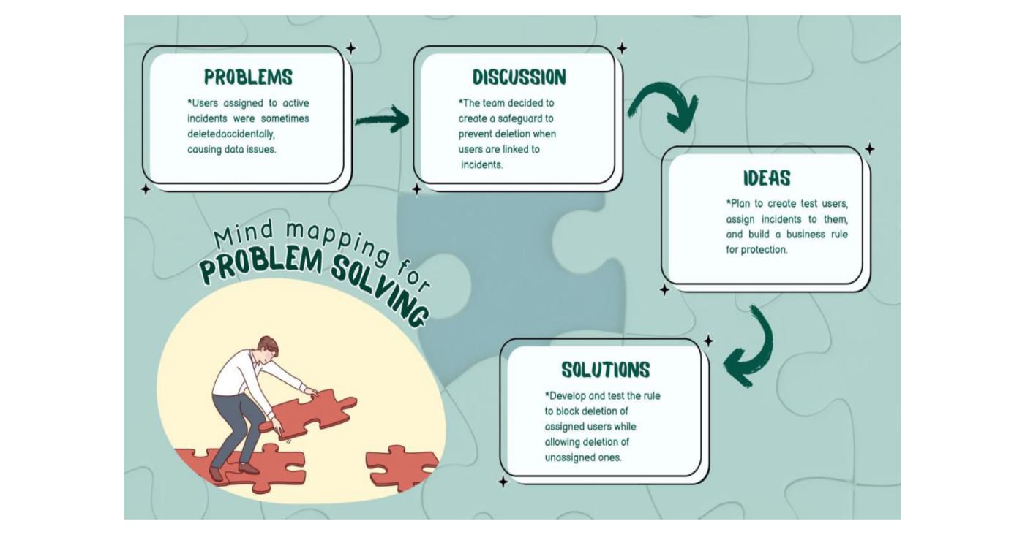
1. Brainstorming
Think broadly about how an education organization could use ServiceNow to improve its operations, services, and communication.
Here are some brainstorming ideas:
- Managing IT help desk requests
- Student self-service portals
- Automating HR and administrative workflows
- Tracking and managing facilities maintenance
- Enhancing communication between departments
- Creating dashboards for performance tracking
- Managing course registration and academic support requests
- Integration with existing systems (LMS, ERP, HRMS, etc.)
- Improving response time for service requests
- Supporting staff and student satisfaction through digital transformation

2. Idea Listing
Let’s list these ideas under key ServiceNow capabilities that fit an educational environment:
A. IT Service Management (ITSM)
- Centralized help desk for technical support
- Automated ticket routing and escalation
- Asset and software license management
- IT incident tracking and resolution
B. Student and Faculty Support
- Student service portal for inquiries and requests
- Faculty support requests (equipment, classroom issues, etc.)
- Knowledge base for FAQs and self-help articles
- Chatbot for 24/7 support
C. Administrative Automation
- HR onboarding/offboarding automation
- Leave and attendance management
- Document approval workflows
- Facilities maintenance requests
D. Data & Reporting
- Dashboards for service performance metrics
- Analytics for identifying trends in requests
- SLA tracking and compliance monitoring
E. Integration & Digital Transformation
- Integrating ServiceNow with existing campus systems (LMS, ERP, email, etc.)
- Centralized digital platform for all campus services
- Reducing paper-based processes
- Enhancing transparency and accountability
Idea Prioritization:
To ensure effective implementation of ServiceNow within an education organization, it is essential to prioritize ideas based on their potential impact, feasibility, and value to institutional goals. The highest priority should be given to establishing the IT Service Management (ITSM) system, including the help desk and ticketing features, as these are quick to implement and deliver immediate improvements in efficiency and user satisfaction. Alongside this, developing a student self-service portal and a knowledge base should also be prioritized, since they significantly enhance the student and faculty experience by providing accessible, on-demand support. In the next phase, attention should shift to administrative and HR process automation, which reduces manual work, minimizes delays, and streamlines internal workflows. Reporting dashboards and SLA tracking should follow, as they add measurable performance visibility and accountability across departments. Lower-priority or later-phase initiatives include integration with existing systems such as the Learning Management System (LMS) or ERP, and the introduction of advanced tools like chatbots, which, while impactful, require more technical resources and planning. Overall, the prioritization strategy begins with foundational modules that provide quick wins, expands into cross-departmental automation for broader efficiency, and culminates in full digital transformation through integration and analytics.

